Row ID Order ID Order Date Ship Date Ship Mode Customer ID \

0 32298 CA-2012-124891 2012-07-31 2012-07-31 Same Day RH-19495

1 26341 IN-2013-77878 2013-02-05 2013-02-07 Second Class JR-16210

2 25330 IN-2013-71249 2013-10-17 2013-10-18 First Class CR-12730

3 13524 ES-2013-1579342 2013-01-28 2013-01-30 First Class KM-16375

4 47221 SG-2013-4320 2013-11-05 2013-11-06 Same Day RH-9495

Customer Name Segment City State ... \

0 Rick Hansen Consumer New York City New York ...

1 Justin Ritter Corporate Wollongong New South Wales ...

2 Craig Reiter Consumer Brisbane Queensland ...

3 Katherine Murray Home Office Berlin Berlin ...

4 Rick Hansen Consumer Dakar Dakar ...

Product ID Category Sub-Category \

0 TEC-AC-10003033 Technology Accessories

1 FUR-CH-10003950 Furniture Chairs

2 TEC-PH-10004664 Technology Phones

3 TEC-PH-10004583 Technology Phones

4 TEC-SHA-10000501 Technology Copiers

Product Name Sales Quantity \

0 Plantronics CS510 - Over-the-Head monaural Wir... 2309.650 7

1 Novimex Executive Leather Armchair, Black 3709.395 9

2 Nokia Smart Phone, with Caller ID 5175.171 9

3 Motorola Smart Phone, Cordless 2892.510 5

4 Sharp Wireless Fax, High-Speed 2832.960 8

Discount Profit Shipping Cost Order Priority

0 0.0 762.1845 933.57 Critical

1 0.1 -288.7650 923.63 Critical

2 0.1 919.9710 915.49 Medium

3 0.1 -96.5400 910.16 Medium

4 0.0 311.5200 903.04 Critical

[5 rows x 24 columns]

Total Sales: 12642501.909880001

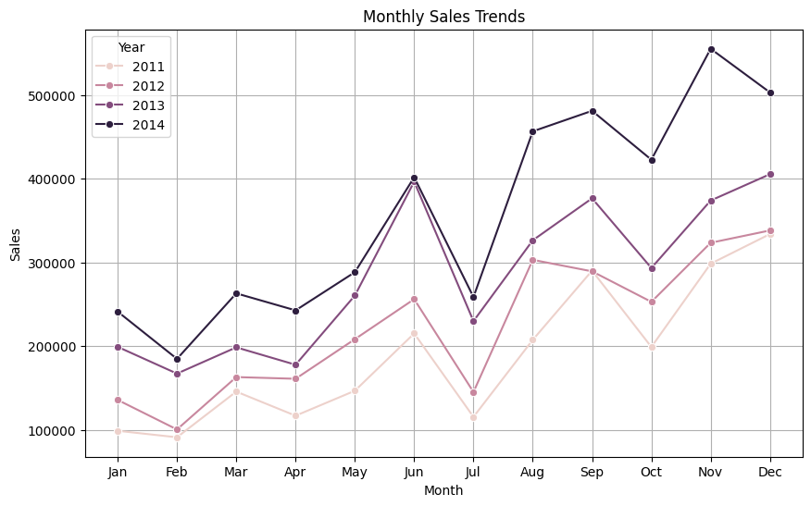

Top 10 Best-Selling Products:

Product Name

Staples 876

Cardinal Index Tab, Clear 337

Eldon File Cart, Single Width 321

Rogers File Cart, Single Width 262

Sanford Pencil Sharpener, Water Color 259

Stockwell Paper Clips, Assorted Sizes 253

Avery Index Tab, Clear 252

Ibico Index Tab, Clear 251

Smead File Cart, Single Width 250

Stanley Pencil Sharpener, Water Color 242

Name: Quantity, dtype: int64

